Title :

Cloud Type Identification Using OpenCV & Keras

Technologies that will be used:

1. OpenCV
2. Keras
3. TensorFlow
4. Python 3

Source:

1. Zhang, Jinglin & Pu, Liu & Zhang, Feng & Song, Qianqian. (2018). CloudNet: Ground-Based Cloud Classification With Deep Convolutional Neural Network. Geophysical Research Letters. 10.1029/2018GL077787.

2. <https://arxiv.org/pdf/1810.05801.pdf>

3. <https://agupubs.onlinelibrary.wiley.com/doi/abs/10.1029/2018GL077787>

4. <https://link.springer.com/article/10.1007/s40747-019-00128-0>

5. https://www.irit.fr/~Herwig.Wendt/data/deep_learning_cloud_detection_icprs_2017.pdf

Algorithm:

Theory:

Clouds have an enormous influence on the Earth's energy balance, climate, and weather. Cloud types have different cloud radiative effects, which is an essential indicator of the cloud effect on radiation. Therefore, identifying the cloud type is important in meteorology.

Types of Clouds:

1. Cumulonimbus
2. Altocumulus
3. Cumulus
4. Cirrocumulus
5. Stratocumulus
6. Stratus
7. Nimbostratus
8. Altostratus
9. Cirrostratus
10. Cirrus

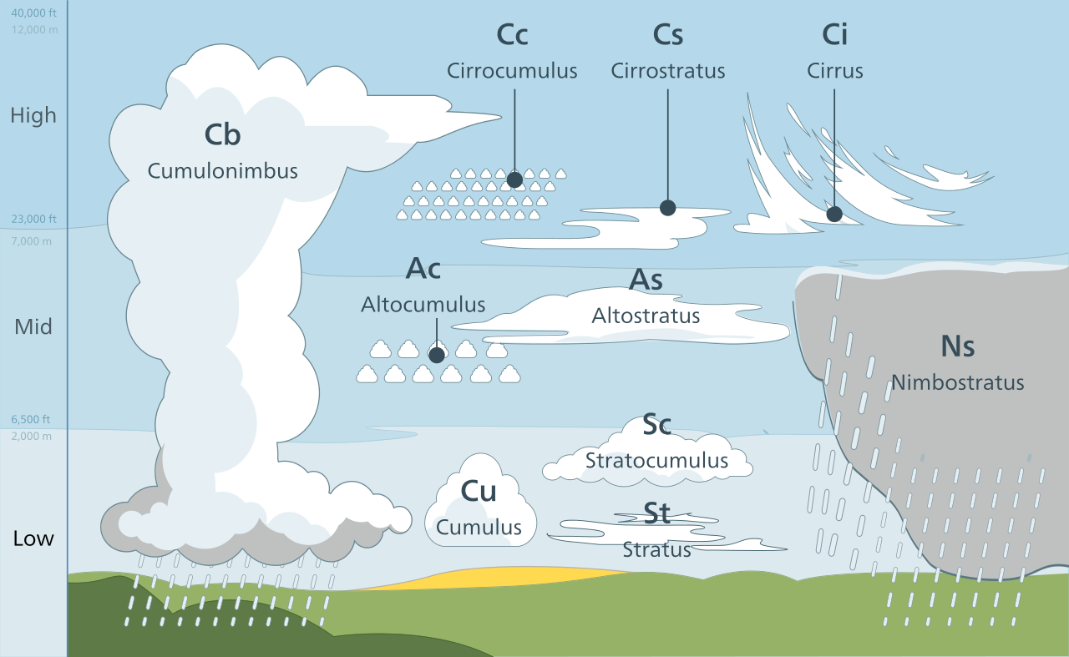

Platform for development & deployment:

Manjaro Linux